CEL 51, DCCN, Monsoon 2020
Lab 6: Subnet and Router Configuration

Harsh Sandesara
Batch C, 49
UID: 2018130045

Topology Diagram

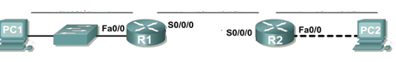

Addressing Table
Device | Interface | IP Address | Subnet Mask | Default Gateway
R1 | Fa0/0 |  | 255.255.255.224 | N/A
R1 | S0/0/0 |  | 255.255.255.224 | N/A
R2 | Fa0/0 |  | 255.255.255.224 | N/A
R2 | S0/0/0 |  | 255.255.255.224 | N/A
PC1 | NIC |  | 255.255.255.224
PC2 | NIC |  | 255.255.255.224

Learning Objectives
Upon completion of this lab, you will be able to:
- Subnet an address space given requirements.
- Assign appropriate addresses to interfaces and document.
- Configure and activate Serial and FastEthernet interfaces.
- Test and verify configurations.
- Reflect upon and document the network implementation.

Scenario
In this lab activity, you will design and apply an IP addressing scheme for the topology shown in the Topology Diagram. You will be given one address block that you must subnet to provide a logical addressing scheme for the network. The routers will then be ready for interface address configuration according to your IP addressing scheme. When the configuration is complete, verify that the network is working properly.
Task 1: Subnet the Address Space.
Step 1: Examine the network requirements.
You have been given the 192.168.1.0/24 address space to use in your network design. The network consists of the following segments:
- The network connected to router R1 will require enough IP addresses to support 15 hosts.
- The network connected to router R2 will require enough IP addresses to support 30 hosts.
- The link between router R1 and router R2 will require IP addresses at each end of the link.
Step 2: Consider the following questions when creating your network design.
How many subnets are needed for this network?
Ans: 3 Subnets are required for this network: the network connected to R1, the network connected to R2, and the link to be established between R1 and R2.

What is the subnet mask for this network in dotted decimal format?
Ans: The address space given is 192.168.1.0/24. The address starts with 192, hence it is a class C network.
Class C networks have a default subnet mask of 11111111.11111111.11111111.x, i.e., The first three octets are dedicated to the network and never change. The 4th octet consists of 1s and 0s in subnet bits depending on the subnet.
We require 3 bits for subnets, so the first 3 bits in the 4th octet are 1, hence the binary form of the subnet mask will be 11111111.11111111.11111111.11100000.
The last 5 bits are for host specification in this case.
Converting 11111111.11111111.11111111.11100000 to decimal form, we get 255.255.255.224. Hence the subnet mask is 255.255.255.224.

What is the subnet mask for the network in slash format?
Ans: Since there are 8*3+3=27 1s in the subnet mask, the slash format is /27.

How many usable hosts are there per subnet?
Ans: The last 5 digits are for hosts. There are 2⁵ = 32 possible combinations, out of which 2 are reserved for the network and broadcast. Hence the number of usable hosts per subnet is 32-2 = 30.

Step 3: Assign sub-network addresses to the Topology Diagram.
- Assign subnet 1 to the network attached to R1.
- Assign subnet 2 to the link between R1 and R2.
- Assign subnet 3 to the network attached to R2.
Task 2: Determine Interface Addresses.
Step 1: Assign appropriate addresses to the device interfaces.
- Assign the first valid host address in subnet 1 to the LAN interface on R1.
- Assign the last valid host address in subnet 1 to PC1.
- Assign the first valid host address in subnet 2 to the WAN interface on R1.
- Assign the last valid host address in subnet 2 to the WAN interface on R2.
- Assign the first valid host address in subnet 3 to the LAN interface of R2.
- Assign the last valid host address in subnet 3 to PC2.
Step 2: Document the addresses to be used in the table provide under the Topology Diagram.
Task 3: Configure the Serial and FastEthernet Addresses.
Step 1: Configure the router interfaces.
Configure the interfaces on the R1 and R2 routers with the IP addresses from your network design. Please note, to complete the activity in Packet Tracer you will be using the Config Tab. When you have finished, be sure to save the running configuration to the NVRAM of the router.
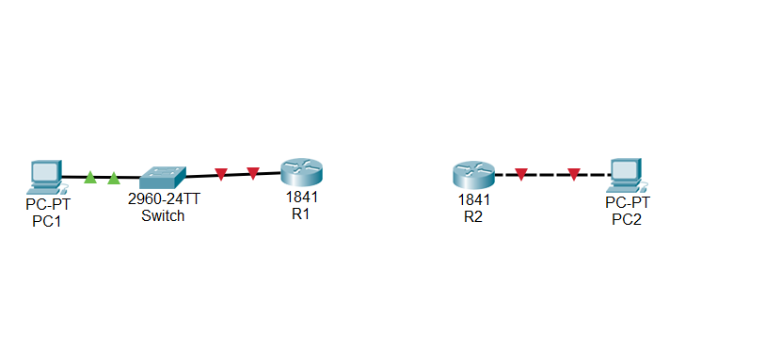
Step 2: Configure the PC interfaces.
Configure the Ethernet interfaces of PC1 and PC2 with the IP addresses and default gateways from your network design.
Task 4: Verify the Configurations.
Answer the following questions to verify that the network is operating as expected.
From the host attached to R1, is it possible to ping the default gateway? ______
From the host attached to R2, is it possible to ping the default gateway? ______
From the router R1, is it possible to ping the Serial 0/0/0 interface of R2? ______
From the router R2, is it possible to ping the Serial 0/0/0 interface of R1? ______
The answer to the above questions should be yes. If any of the above pings failed, check your physical connections and configurations.

Task 5: Reflection
Are there any devices on the network that cannot ping each other?
__________________________________________________________________________
__________________________________________________________________________

What is missing from the network that is preventing communication between these devices?
__________________________________________________________________________
__________________________________________________________________________

